Brent Colbert
Math 1040 Term Project
Purpose:
My research question is "Is the price of soup related to the amount of ingredients?"
My first numerical variable is the price of soup. The unit of measurement for this variable is dollars. A few possible values for this variable are $3.99, $1.89, and $5.99. My second numerical variable is the number of ingredients in each soup. The Unit of measurement for this is the number of ingredients. A few possible values for the second numerical variable are 12, 28, and 20.
My prediction was that there is no correlation between the price of soup and amount of ingredients, that there is not necessarily more ingredients in more expensive soup.
To gather the price and number of ingredients of soup randomly, I selected data from 5 randomly selected cans of soup from 6 different grocery stores in Salt Lake City (Sprouts, Whole Foods, Smiths, Trader Joes, Target, Wal Mart). I tried to do this as randomly as possible all from grocery stores in Salt Lake City. I chose all cans of soup and did not have any other factors of selecting.
Price | # of Ingredients
0.69 | 17
0.69 | 20
0.69 | 13
0.99 | 9
0.99 | 6
0.99 | 18
0.99 | 11
1.09 | 12
1.29 | 14
1.29 | 18
1.49 | 17
1.49 | 14
1.49 | 14
1.79 | 24
1.79 | 16
1.99 | 21
1.99 | 27
1.99 | 15
1.99 | 14
1.99 | 16
1.99 | 11
2.09 | 25
2.09 | 16
2.29 | 13
2.49 | 10
2.99 | 18
3.29 | 15
3.99 | 12
3.99 | 17
4.99 | 17

1.Summary statistics:
Column | n | Mean | Variance | Std. Dev. | Std. Err. | Median | Range | Min | Max | Q1 | Q3
Price | 30 | 1.93 | 1.0907586 | 1.0443939 | 0.19067937 | 1.89 | 4.3 | 0.69 | 4.99 | 1.09 | 2.09

Mode:$1.99 Outliers: $3.99, $3.99, $4.99
1a.) I would use the median for the center because there are outliers.
2)
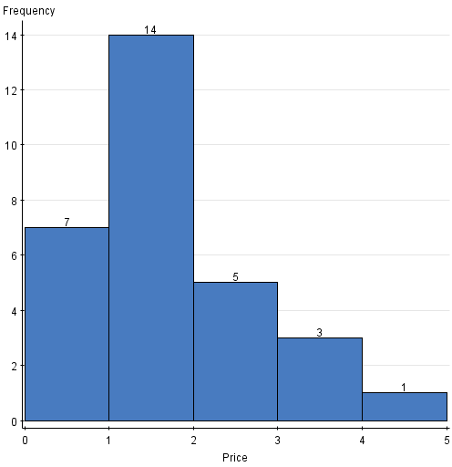

3)
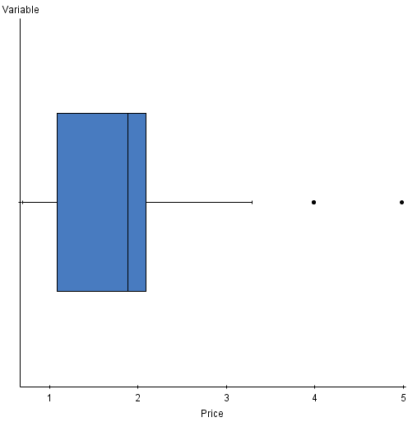
4)
Summary statistics:
Column | n | Mean | Variance | Std. Dev. | Std. Err. | Median | Range | Min | Max | Q1 | Q3
# of Ingredients | 30 | 15.666667 | 21.471264 | 4.6337094 | 0.8459957 | 15.5 | 21 | 6 | 27 | 13 | 18
Mode:14 Outliers:27
4a) I would use the median for the center because there are outliers.

5)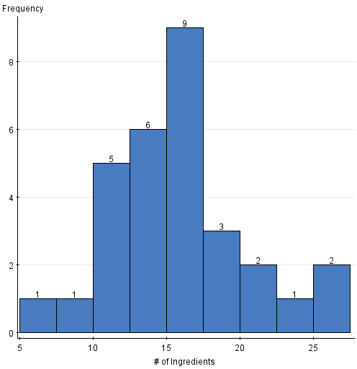666666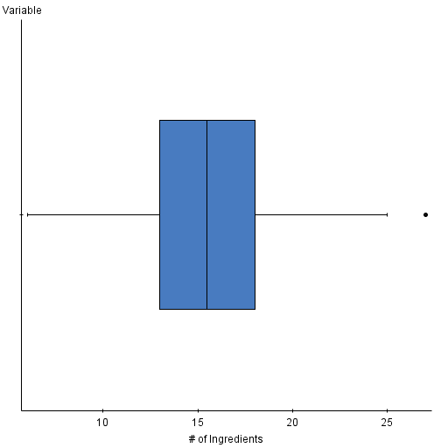

7.# of Ingredients = 14.751454 + 0.47420335 Price
R (correlation coefficient) = 0.1069

8)

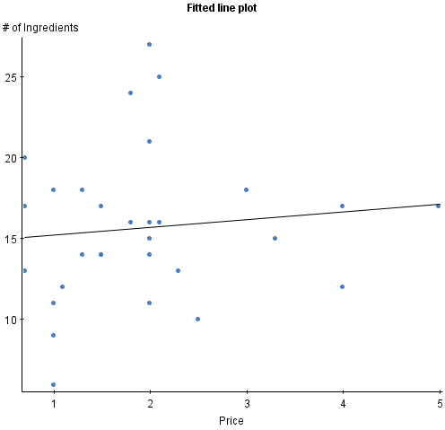
9) 14.751454 + 0.47420335(Price)
Analysis: There is a lack of correlation between the price of soup and the amount of ingredients.
To answer the original question "Is the price of soup related to the amount of ingredients?" The statistics did support my original hypothesis of weak correlation (R value .1069). The difficulties I faced were to not take a convenience sample. Instead, to make it as random as possible, I went to 6 different stores to sample. If I had to complete a similar study in the future I would be more specific about the kinds of soup sampled since there are so many factors/variables involved in sampling soup (ex. Is the price of 10.5 oz cans of Campbell’s soup related to the number of ingredients? )

